CS551 Advanced Software Engineering

Second Increment Report
Due Date: October 18 (F) 2013, 11:59PM

Contributors: Shiva Pothala, Karthik Repala, Surendra Koripella.

- Import Existing Services/API

API's used:
1. Google Maps API

Services Implemented:

- Find my Car Service.

- Detail Design of Services

  - Write User Stories /Use Case (Using ScrumDo)

  - Sequence diagram (using Visio)

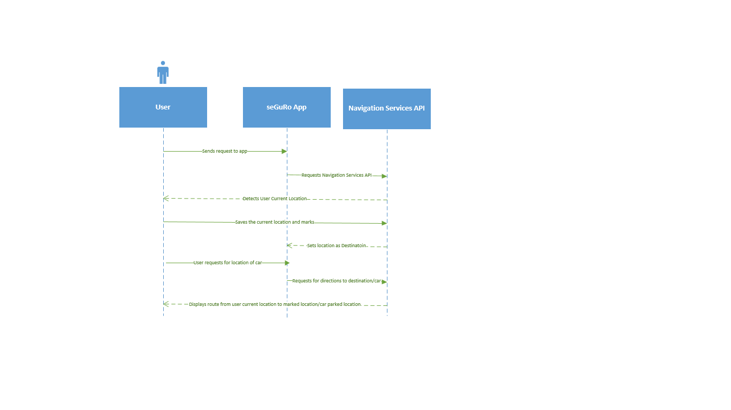

  - Class Diagram

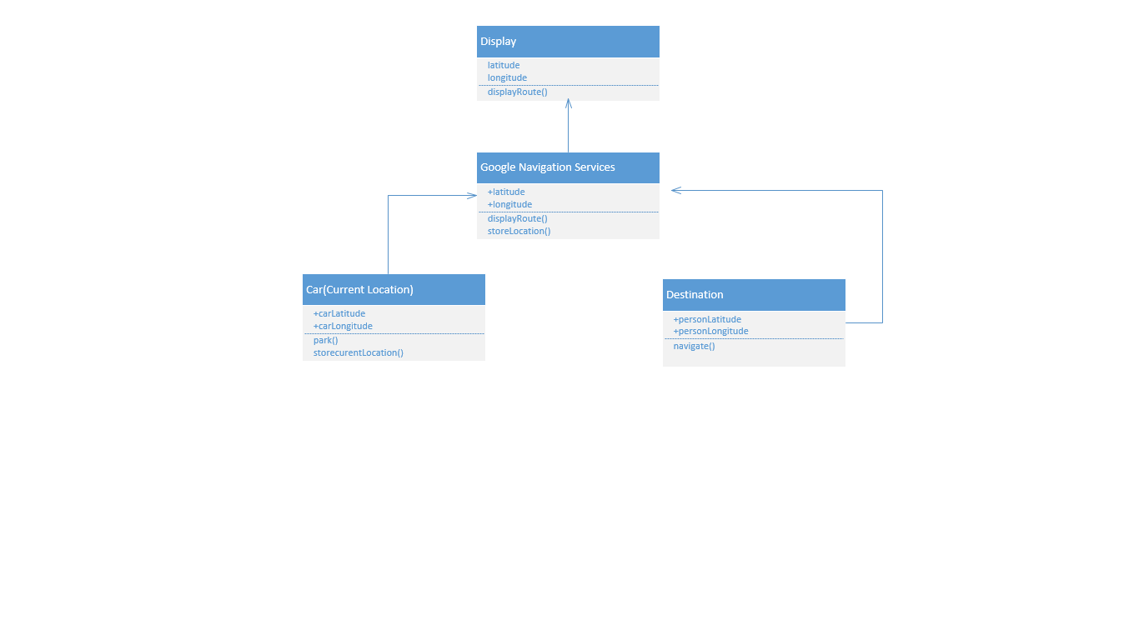

- Implementation
  - Implementation of services
  - Implementation of user interface (Mobile Apps)
  - Implementation of test cases

- Report:

Screen Shot Find My Car App:
The Map displays the navigation from the car parked location to the university.

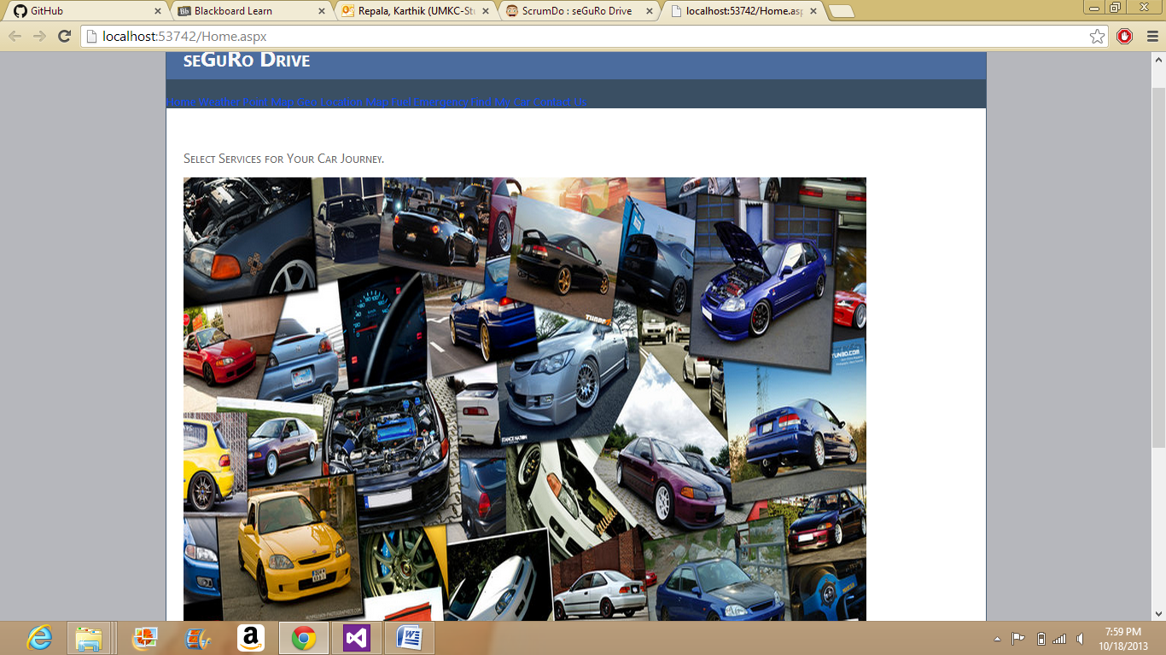

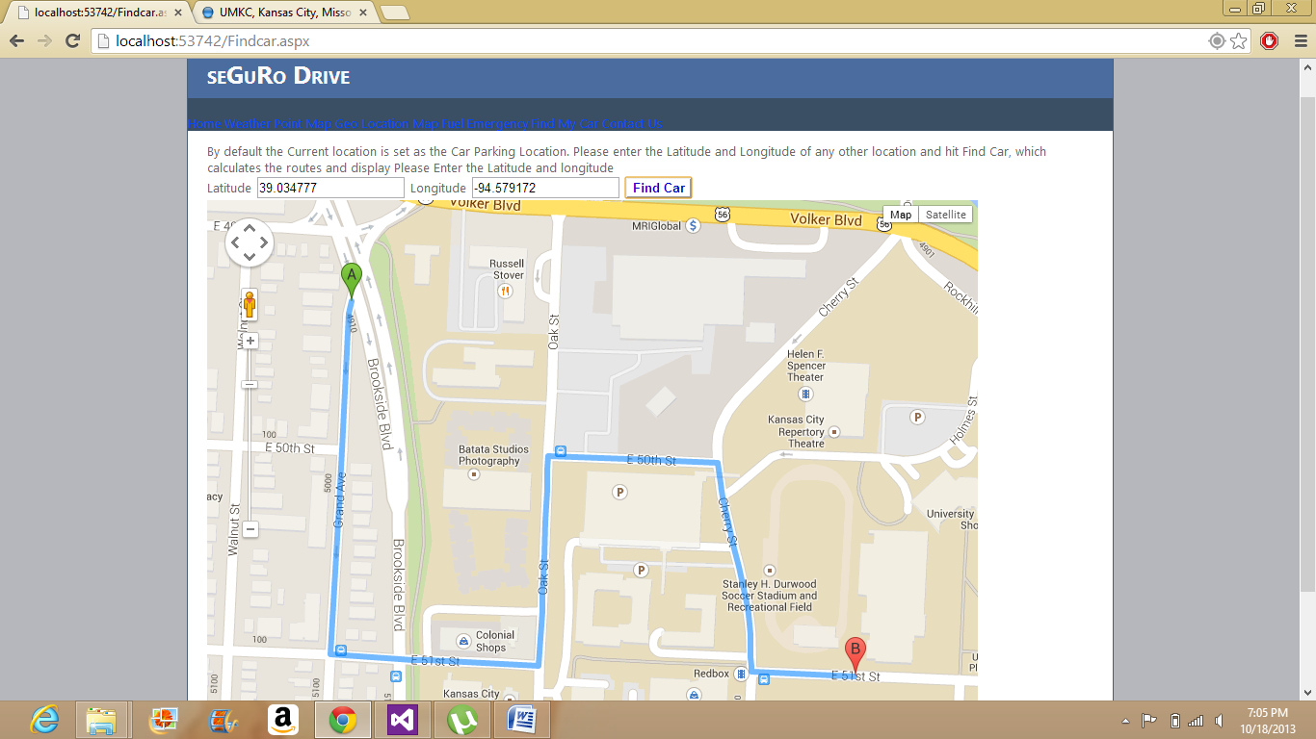

- Project Management:

Story #3 As a team we want to develop and test Navigation services and Parking services so that it can be integrated with the seGuRo Drive App.

Before changes to scrumDO:

In the First increment of the project only navigation services were implemented, hence the story was moved to the Doing State.
Now as part of the second increment, find my car solution is also implemented, hence story 3 will be moved to Finished State.

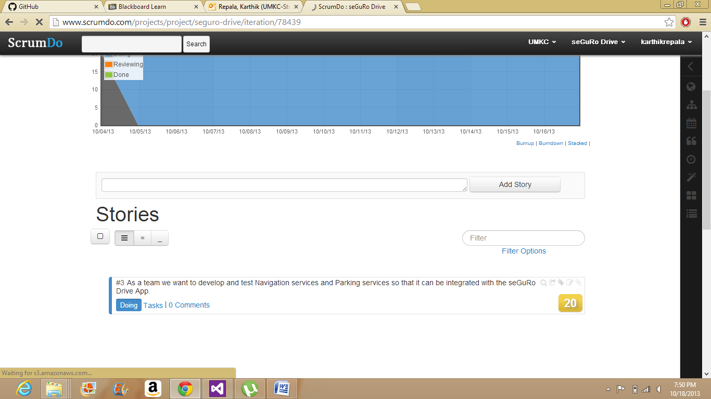

After Second Increment, Changes in ScrumDo:
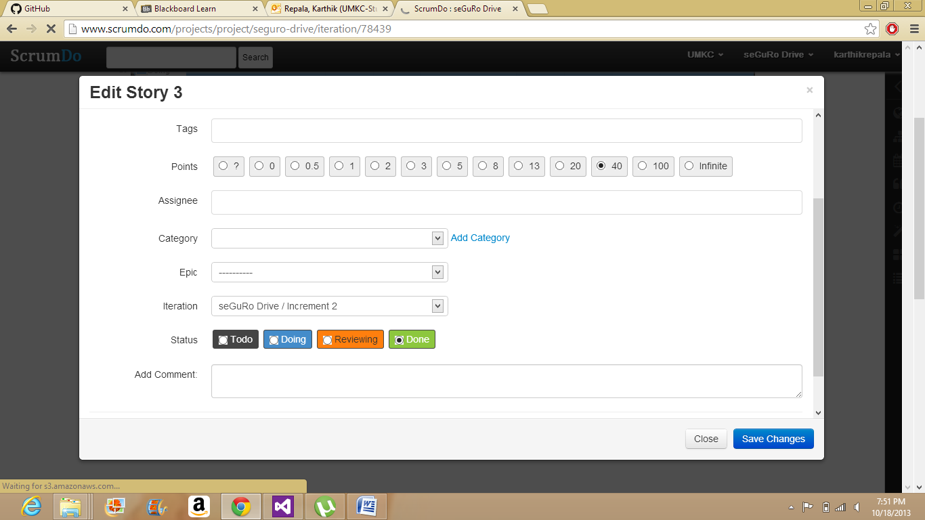

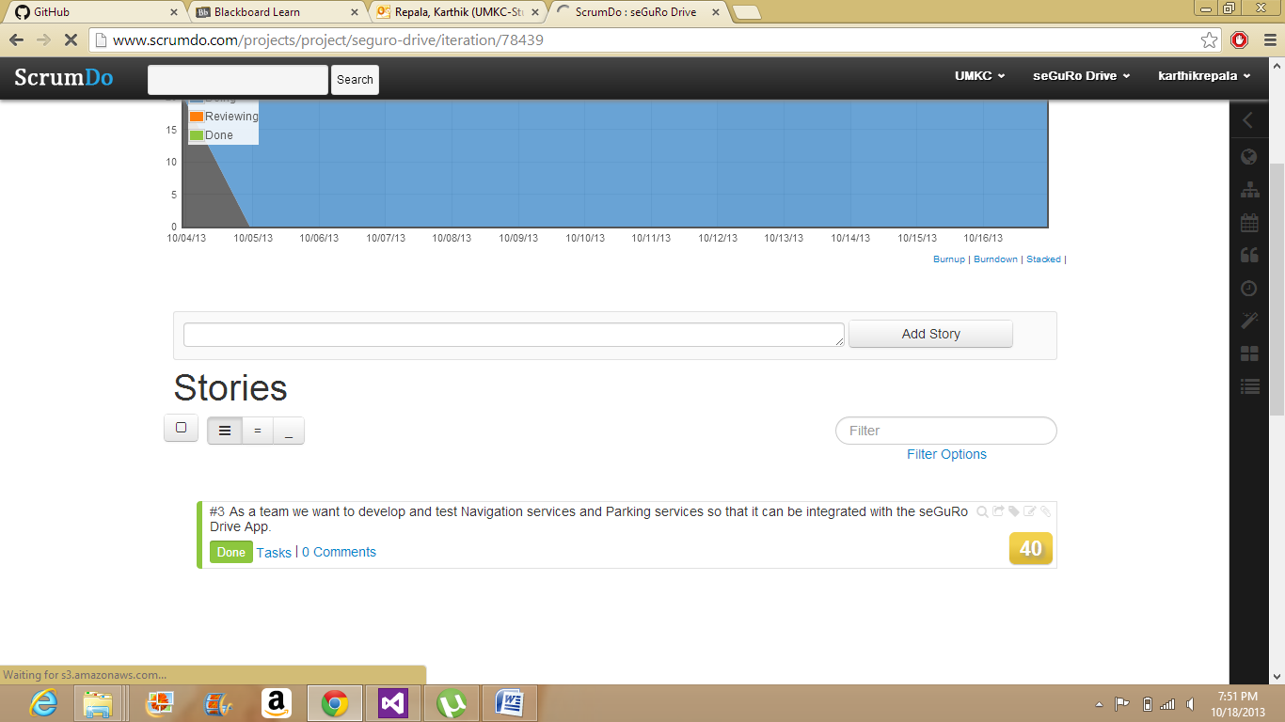

The Increment 2 shown in the below screen shot depicts the completion of Second Increment as per the scheduled dates.
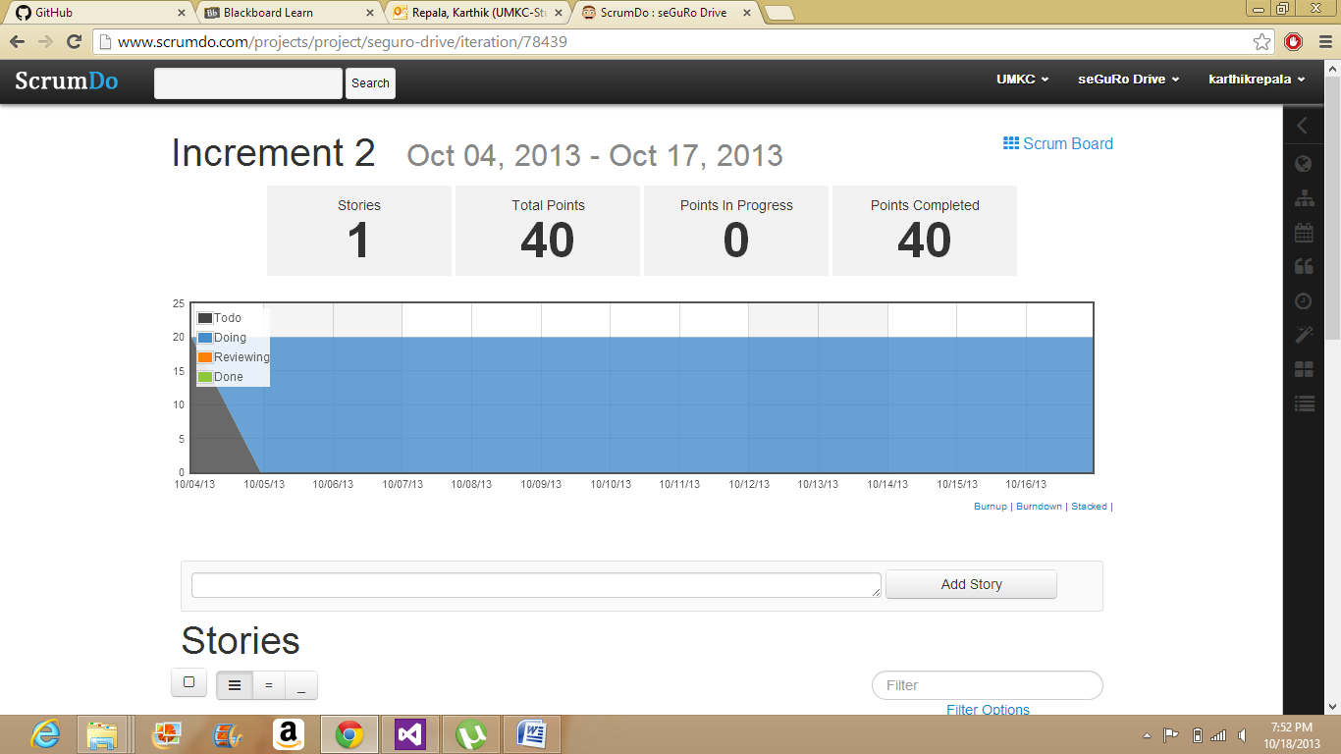

  - Implementation status report

    - Work completed:
      - Find My Car Service
      - Time taken (40 hours)
      - Responsibility
Shiva - Documentation, Unit Testing
Karthik - Coding, Project Diagrams
Surendra - Cloud Deployment, Project Diagrams

    - Work to be completed
      - Fuel Monitoring, Emergency Services
      - Responsibility (Share Equally)
      - Time to be taken (100 hours)

    - Issues/Concerns:

- Front End should be designed as we progress to the end.
- Integration of all modules into cloud.
- Overall Testing needs to be performed.

